This report compares the manually-built GreenPrint GUI (Part A) with the AI-generated GUI (Part B). Both versions implement the same three tab JavaFX interface using the same model classes (EmissionSource, FootprintTracker, and subclasses) from Assignment 1. The AI tool used for Part B was Claude (claude.ai).
Criterion | Manual GUI (Part A) | AI GUI (Part B) | Evaluation Details
Code Structure & Readability | Good | Functional | Part A uses helper methods (makButton, makLabel) consistent with the team style. Part B generated more verbose code with extra fields and less consistent naming.
GUI Layout & Visual Quality | Functional | Cleaner | Part A uses FlowPane + VBox which causes elements to overflow. Part B uses VBox + GridPane giving a more structured layout.
Feature Completeness | Full | Full | Both versions implement all three tabs: Dashboard, Input, and Offset Transaction with all required elements.
Input Validation & Error Handling | Good | Good | Both versions show real-time validation with green/red labels. Part A uses Alert popup for confirmation. Part B shows status in a Label.
Responsiveness & UX | Functional | Good | Part A window is fixed size (1000x777). Part B is resizable and adapts better. Part A layout shifts when adding entries. Part B dashboard requires app restart to show new entries.
Development Time | 5 hours | 1 hour | Part A required manual coding of all logic and layout. Part B required prompting, reviewing, and fixing AI output which was significantly faster.
AI Prompting Quality | N/A | Good | 4 prompts were sent total with 1 refinement. Prompts were specific and included package names, class requirements, and method names. 5 iterations total.
Required Human Edits to AI Output | N/A | 4-5 fixes | Main fixes: replaced Thread.sleep with PauseTransition, removed TitledPane, fixed split('|'), added LoggerUtil calls.

Screenshots:
Part A - Manual GUI:
Screenshot 1: Input tab 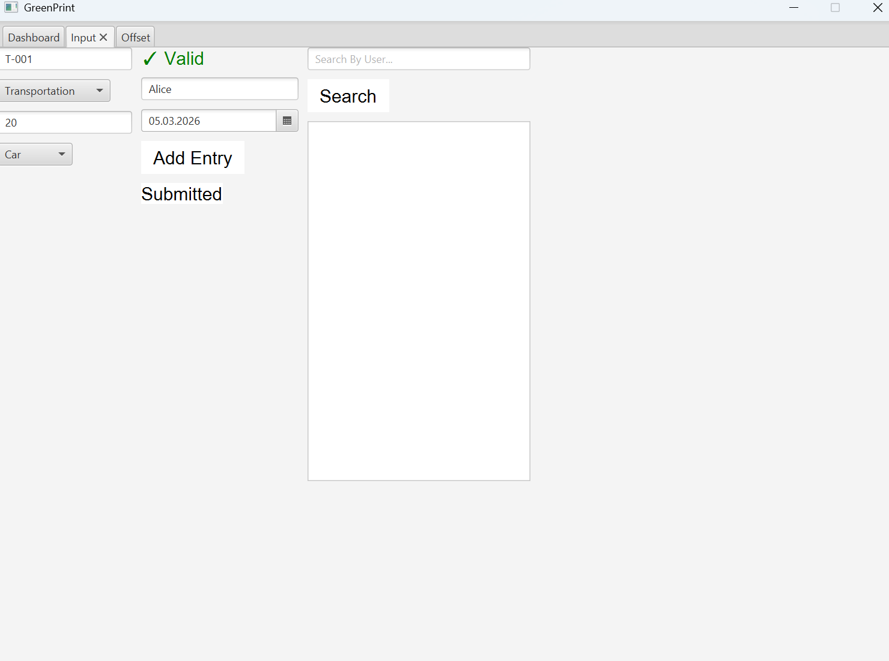
Screenshot 2: Dashboard tab
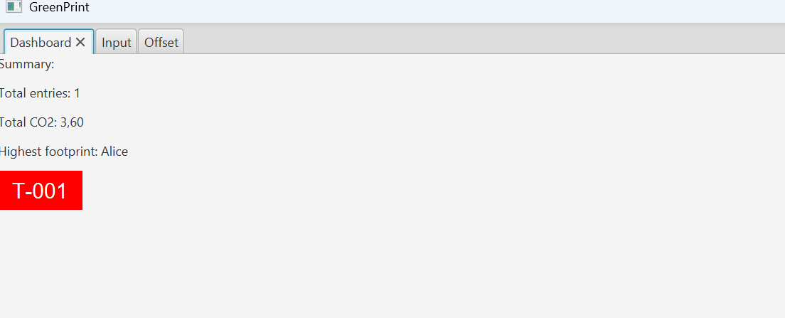
Screenshot 3: Offset tab
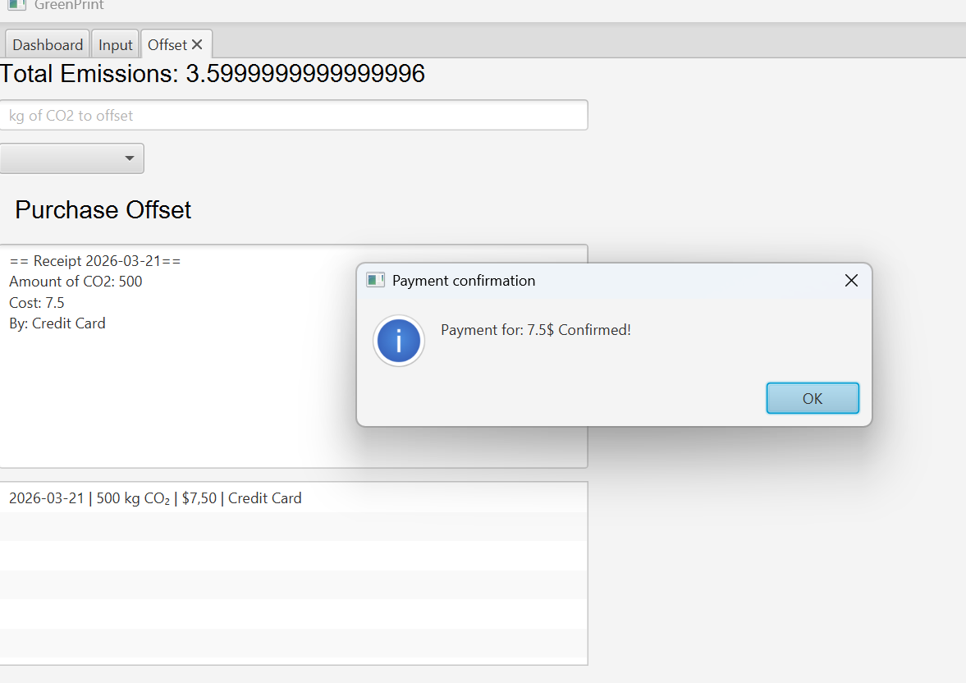

Part B - AI GUI:
Screenshot 4: Input tab
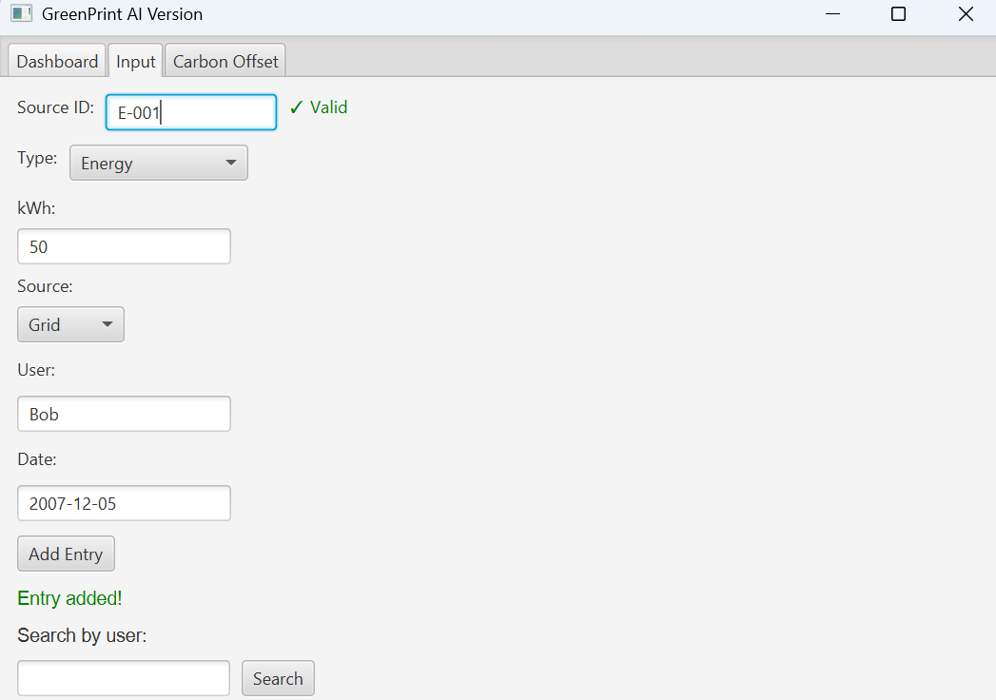
Screenshot 5: Dashboard tab
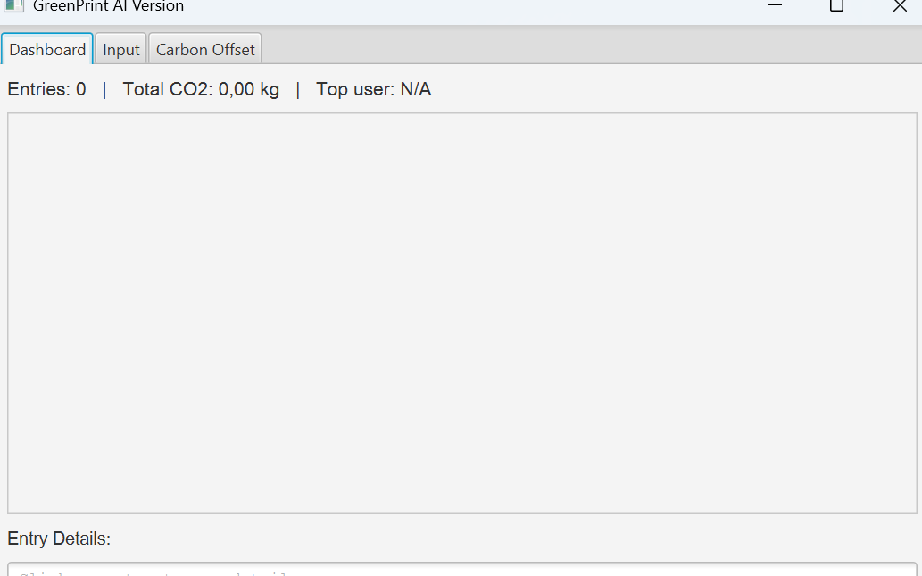
Screenshot 6: Carbon Offset tab
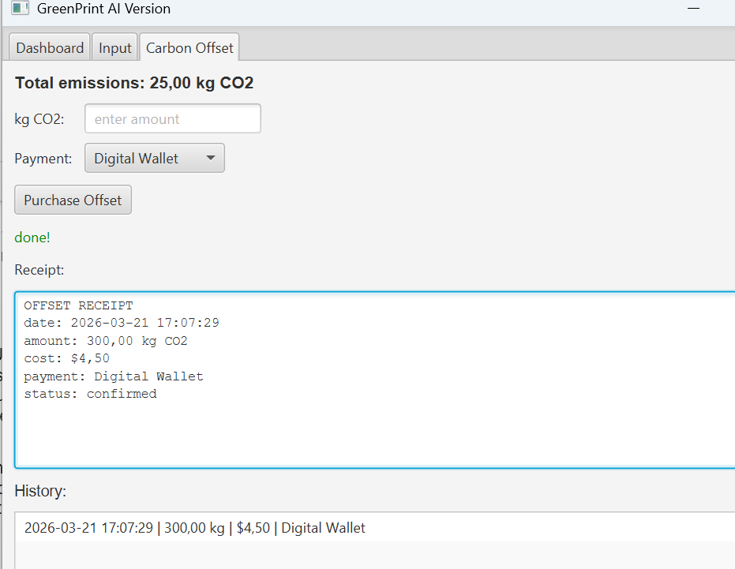

Reflection:
Overall, Part A felt more natural since we wrote it ourselves and it matches the style of our other files. Part B had a cleaner layout in some tabs but we had to fix several things before it even compiled. AI was good at generating the basic structure fast ( layouts, buttons, comboboxes and event handlers) were mostly correct. It saved a lot of time on the repetitive parts. The main issue was that AI did not know our class restrictions. It used Thread.sleep instead of PauseTransition, added TitledPane which we never learned. These were not hard fixes but we had to actually read and understand the code to catch them. We would use AI again for GUI development but only as a starting point. You still need to check everything it generates especially when the project has specific rules.

